**ASSIGNMENT-3**

Group A Python Program for Matrix Addition, Substraction, Multiplication and Transpose

**PROBLEM STATEMENT:**

WRITE A PYTHON PROGRAM TO COMPUTE FOLLOWING COMPUTATION ON

MATRIX:

A) ADDITION OF TWO MATRICES

B) SUBTRACTION OF TWO MATRICES

C) MULTIPLICATION OF TWO MATRICES

D) TRANSPOSE OF A MATRIX

**ANALYSIS OF A PROBLEM STATEMENT:**

1. Given :

Matrices are given in a problem statement.

2. Entity:

Matrix is an entity or object with no of rows and no of columns attribute.

3. Input:

You have to accept n x n matrix values from the user to perform operations on it.

4. Data Structure:

To store/organize the matrix element in memory we required LIST as a data structure.

5. Output:

5.1 Addition of two Matrices

5.2 Subtraction of two Matrices

5.3 Multiplication of two Matrices

5.4 Transpose of a Matrix

**CODE:**

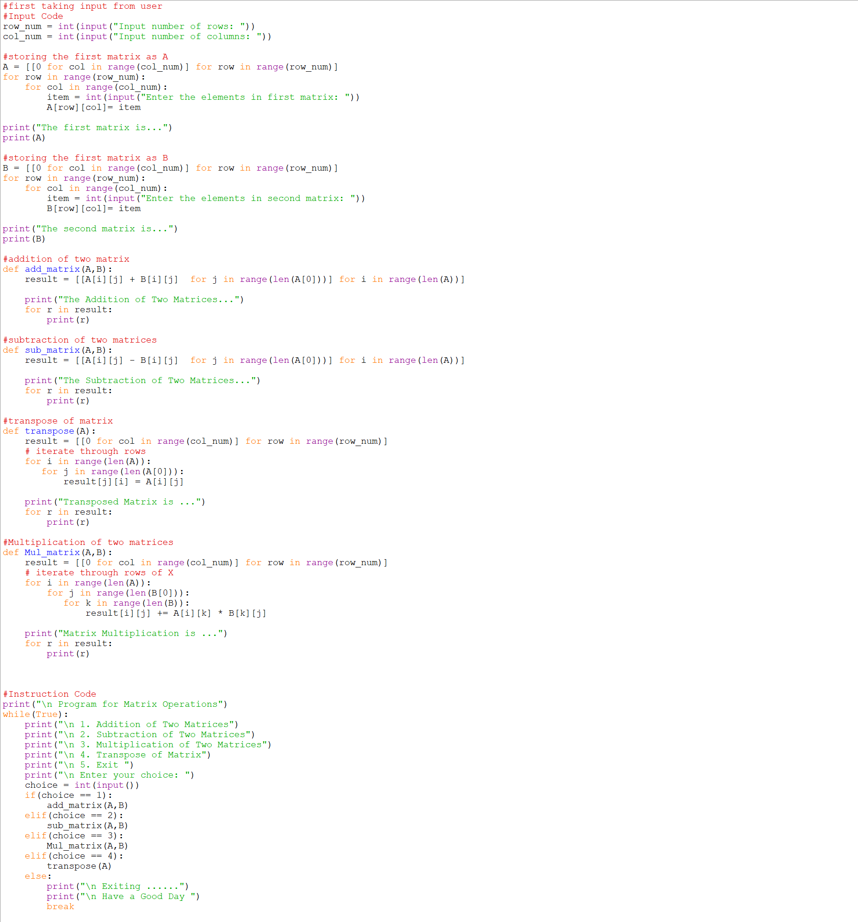

**OUTPUT:**

